Product:
Hangers Doors / Extra Large Opening Doors

VISION PANELS
Standard sizes:
- S-800: 800x800, 800x1600, 1300x800, 1300x1600 (WxH)
- S-1000: 800xIPD 1300xIPD (Width x Intermediate Profile Distance)
- S-1500: Width 800 and 1300, maximum height = IPD, always check with Megadoor

Characteristics:
Type Elaston 064, 1 mm
Weight 1230 g/m2
Hardness 77 o Shore acc to DIN 53505
Tear resistance along/crosswise 21 / 20 N/mm2 acc to DIN 53455
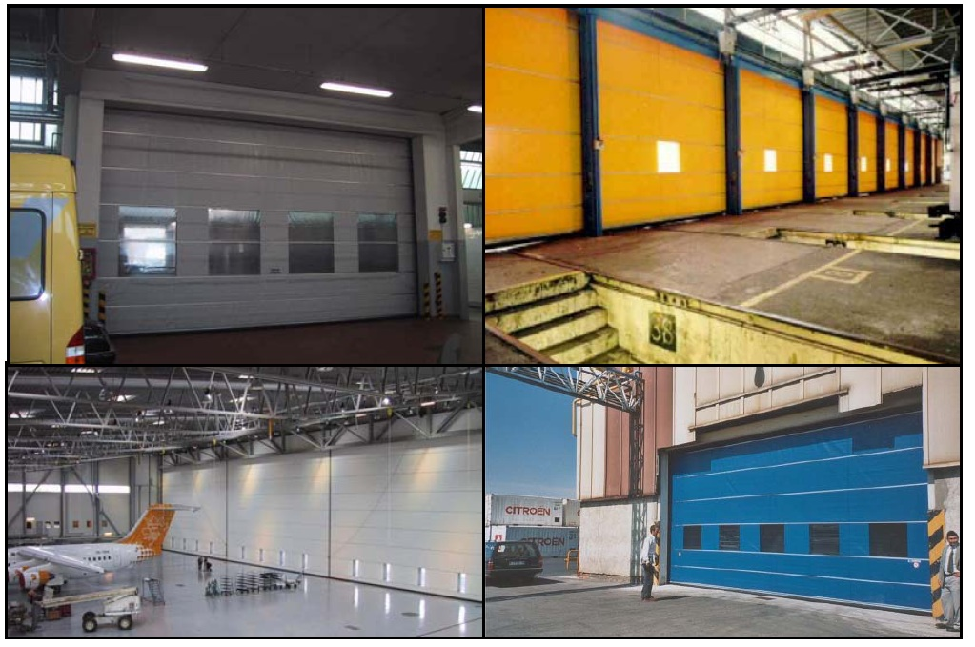
Temp. range -30 - +50oC

Megadoor reserves the right to make changes to this document without notice.
Latest update: 2003-11-20 /MS

